AWS TECHNICAL ESSENTIALS
Parts 1 & 2 — Study Notes

AWS BASICS

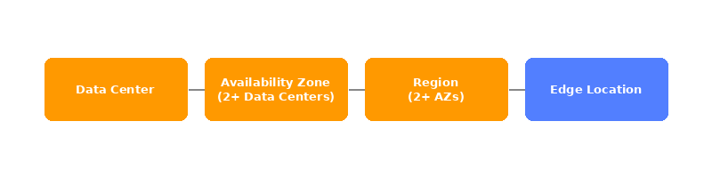

 | Data Center  A server.

 | Availability Zone / AZ  A cluster of 2 or more data centers.

 | Region  A cluster of availability zones.

 | Edge Location  A "middle men" between the region and the user. it's a location where you can small amount of data you need to have ready for the user at all time (popular data/mostly used).

 | API  The way to interact with AWS. Every interaction with AWS is an API call.

Ways to interact with AWS
1. AWS Management Console – the most basic way, interacting through the main page in AWS.
2. CLI – a script you can schedule to do as you want, it's a simple way to automate the process of pulling up basic day to day resources and mundane tasks that need to be done.
3. SDK – SDK allows you to write code in one of the supported languages and interact with AWS through code. It lets you simply write your action into AWS.

USERS

 | MFA  An authenticator app which gives a one time code that is used to log into the AWS account, it is combined with the password and email address of the user while logging in to help make the account more secure and harder for unwanted personal to get into.

 | Root User  The main user of the account, has access to every part of the account and is able to do as he pleases.

INSTANCE TYPES

Instance Families
General Purpose — balanced CPU/memory/network
• t series (t3, t4g) — burstable, cheapest, great for small apps/dev environments
• m series (m6i, m7g) — steady workloads, most common for production
General purpose instances provide a balanced mix of compute, memory, and networking resources. They are ideal for diverse workloads, like web services, code repositories, and when workload performance is uncertain.

Compute Optimized — high CPU relative to memory
• c series (c6i, c7g) — batch processing, gaming servers, high-traffic web servers
Compute optimized instances are ideal for compute-intensive tasks, such as gaming servers, high performance computing (HPC), machine learning, and scientific modeling.

Memory Optimized — high RAM relative to CPU
• r series (r6i, r7g) — databases, caching (Redis), big data
• x series (x2idn) — extreme memory, SAP HANA, in-memory DBs
• u series — ultra-high memory (TBs of RAM)
Memory optimized instances are used for memory-intensive tasks like processing large datasets, data analytics, and databases. They provide fast performance for memory-heavy workloads.

Storage Optimized — high local disk I/O
• i series (i4i) — NoSQL databases, data warehousing
• d series — dense HDD storage, Hadoop
• h series — high disk throughput
Storage optimized instances are designed for workloads that require high performance for locally stored data, such as large databases, data warehousing, and I/O-intensive applications.

Accelerated Computing — GPUs / special hardware
• p series (p4, p5) — ML training, HPC
• g series (g5) — ML inference, video rendering, gaming
• inf series (inf2) — AWS Inferentia chip, optimized for ML inference
• trn series — AWS Trainium chip, ML training
Accelerated computing instances use hardware accelerators, like graphics processing units (GPUs), to efficiently handle tasks, such as floating-point calculations, graphics processing, and machine learning.

HPC (High Performance Computing)
• hpc series — tightly coupled HPC workloads, high-speed networking

How to read an instance name
Example: m6i.2xlarge m → family (General Purpose) 6 → generation (newer = better price/performance) i → processor modifier (Intel; a = AMD, g = Graviton/ARM) 2xlarge → size

Sizes
The bigger the size the more CPU, RAM, NETWORK BANDWIDTH AND EBS you have the ability to use.

Symptom | What to scale
High CPU usage | Bigger size or compute-optimized (c family)
High RAM usage / swapping | Bigger size or memory-optimized (r family)
Slow network | Bigger size
Slow disk I/O | Bigger size or storage-optimized (i family)

Tip: it's better to start small then scale up if needed

Spot Instances -Bid on spare compute capacity at up to 90 percent off the On-Demand price, with the flexibility to be interrupted when AWS reclaims the instance.

EC2 INSTANCE LIFECYCLE

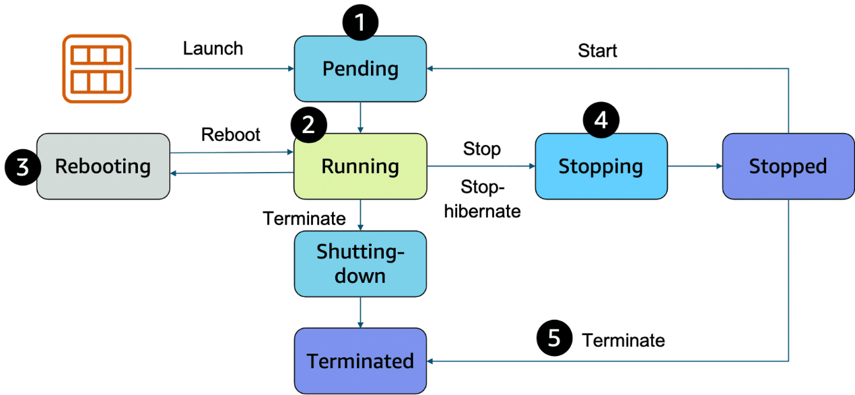

An EC2 instance transitions between different states from the moment you create it until its termination.
1. Pending – the setup for the EC2, you're not billed yet.
2. Running – it's ready to be used and is billing you, you can stop, reboot and shut it down now.
3. Reboot – it's like rebooting a computer, it saves all the data stored before and keeps the same public or private IP and host computer.
4. Stop – it's like closing down your laptop, it is possible it will be placed in a new physical server. It saves its IP address and last data stored on it BUT RAM is wiped — it will need a full OS boot next time it is started.
5. Stop Hibernate – the difference is that it's ready to open and resume without needing a full OS boot, RAM is stored in the EBS and restored from there.
6. Terminated – you cannot use the machine anymore, you will lose its IP, it will not bill you and all information on it is erased.

When to use which
• Stop → most common, fine for servers/apps that boot fast and don't need state preserved
• Hibernate → useful when you have a long-running process or heavy in-memory state you want to resume quickly (e.g., a dev environment with many things open, or a long computation paused mid-way)

Decoupling services - In modern application development, reliability and resilience are important. One effective way to achieve this is by adopting a service-oriented approach. These services help us do that:

EventBridge - EventBridge is a serverless service that helps connect different parts of an application using events, helping to build scalable, event-driven systems. With EventBridge, you route events from sources like custom apps, AWS services, and third-party software to other applications. EventBridge simplifies the process of receiving, filtering, transforming, and delivering events, so you can quickly build reliable applications.

Amazon SQS - Amazon SQS is a message queuing service that facilitates reliable communication between software components. It can send, store, and receive messages at any scale, making sure messages are not lost and that other services don't need to be available for processing. In Amazon SQS, an application places messages into a queue, and a user or service retrieves the message, processes it, and then removes it from the queue.

Amazon SNS - Amazon SNS is a publish-subscribe service that publishers use to send messages to subscribers through SNS topics. In Amazon SNS, subscribers can include web servers, email addresses, Lambda functions, and various other endpoints. You will learn about Lambda in more detail later.

CONTAINERS

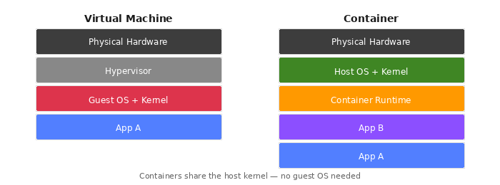

 | Virtual Machines / VM  A computer running in a data center you're connected to, like an EC2. They have a kernel and an OS system.

 | Kernel  The base of an OS system and is installed on the VM, is NOT installed in a container.

 | Containers  A container is a way to package an application with everything it needs to run, it contains a mini runtime environment with its code, tools, images and more, it connects to the host computer and runs using Linux. If your computer doesn't have Linux (windows, mac) you use a tool (usually docker) to run a Linux VM to use as the kernel. It does NOT include a kernel and relies on the host to have one or a tool to install it.

Analogy — Think of an apartment building: Kernel = the building's infrastructure (electricity, plumbing, elevators) Docker = the building manager (assigns apartments, sets rules) Container = a tenant (lives independently, but shares the building's infrastructure) The manager doesn't become the electricity — he just manages who uses it and how much.

 | ECS  A tool made for AWS to run containers on EC2, it is only on AWS and is simpler than EKS, it is also able to run on Linux and windows AMI. In ECS a container is called a task.

 | EKS  The industry standard for running containers, it is an open source platform that is more popular and more complex and expansive than ECS. Containers running on it are called pods.

 | ECR  A place to store container images, EKS & ECS both can pull from it.

 | AWS Fargate  Fargate manages the EC2 scale and instances that way you can focus on the containers and uses of ECS & EKS.

 | Lambda  A lambda is a function to which you can create triggers that will make sure that LAMBDA only starts to work when they are activated (like an if statement in coding). You only get billed for when it's used.

NETWORKING

 | IPv4 Notation  A decimal number built out of a 32 bit binary format IP address — 4 different binary numbers each one made of 8 1s & 0s.

 | CIDR Notation  CIDR lets you express a range of IP addresses. It does that by putting a "/" before the flexible range — when you subtract the number after "/" from 32 you get the amount of flexible bits left in the address. The higher the number after "/", the smaller the amount of flexible bits.


 | VPC (Virtual Private Cloud)  An isolated network that you can create in AWS, it mirrors a traditional network in a data center.

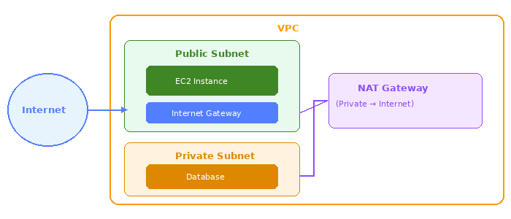

Subnets
There are two types of subnets in a VPC:
• Private — can only connect to the internet via NAT gateway, more secure.
• Public — can be connected to the net via an internet gateway.

 | Internet Gateway  A way to connect the VPC and through it the public subnet on it to the net.

 | Virtual Private Gateway  A way to connect your VPC to a private network (office, home etc.). It does require a physical device or software (AWS Direct Connect for example) on the customer side to let you use a VPN to connect to the VPG and through it to the VPC.

 | AWS Direct Connect  A program by AWS that lets you connect your internal network such as home or office network to the VPC or AWS services.

 | Main Route Table  When a VPC is created AWS creates a main route table with it to help route out the network traffic in and out of it. AWS on default allows traffic between all subnets in the local network. The main route table has rules such as: you cannot delete it OR replace it, you can add modify or delete routes in it, and you can change which subnets are associated with it.

 | Custom Route Tables  If you want to change the route of flow to a subnet you can create a custom route table, using it you are able to create different routes for the subnet and if a route is created for a subnet it will use it instead of the main one, keeping the VPC more protected and organized.

 | ACL  The ACL acts as a cyber firewall around the subnets controlling what is allowed in and out, the default settings allows free flow with no restrictions. An ACL is stateless which means that when you configure it it's important to include inbound AND outbound gates so that traffic has a way of leaving the subnets once it's done.

 | Security Groups  Just like ACL is for subnets, security groups does the same for EC2 — it acts as a firewall protecting and segregating an EC2. Because they are stateful unlike ACL you are allowed to create only an inbound port without creating an outbound one. Security groups block all inbound and outbound traffic on default.

AWS TECHNICAL ESSENTIALS — PART 2
STORAGE

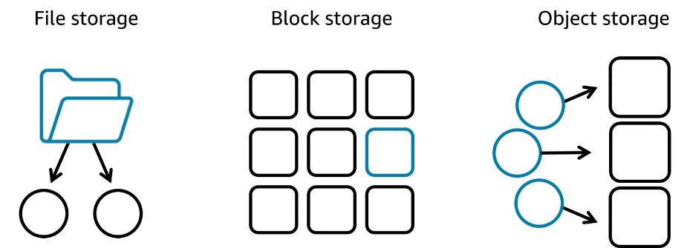

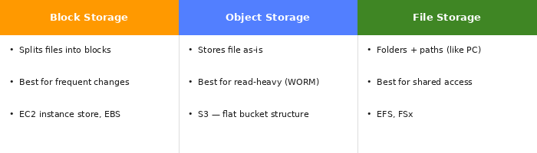

 | Block Storage  Block storage is built in a way that splits the file up into smaller blocks — thus any changes done to the file will be done on the smaller block and not the entire file. Because of that it is the perfect candidate for storing files that need to be changed a lot. Also good for storing containers because of their nature.

 | Object Storage  Object is different than block in the way it organizes the file. In object the file is stored in the same form it is given without being cut or changed, that makes it better for files that need to be read a lot but changed little (WORM = Write once Read many). The object itself is stored in a bucket using a flat structure — unlike file storage there is no path or directories, each one has a unique identifier that is bundled with the rest of the data and is stored together.

 | File Storage  File is our basic way of storing just like it is done on any normal computer, it works on folders and sub folders where each file has its own metadata like name, size and more. It also has a path that the system knows to make retrieving it easier when needed. Best used when you need a centralized storage system that is easy to share info through and can be used by multiple host computers.

File Storage Services
 | Amazon EFS  Amazon's app for file storage system, it can grow and shrink its storage size depending on its need. It has multiple storage classes like standard which works in multiple AZ zones, and one zone storage which works in only one AZ to make access easier.

 | Amazon FSx  FSx works much like EFS but has compatibility with windows, higher performance such as using Lustre and is in general more compatible than EFS which is the main reason to use it.

EC2 Storage
 | EC2 Instance Store  On every EC2 instance there is a storage attached, it is built like that so you can connect to the data faster and to keep high performance since it's all stored locally on the EC2. That means that if the instance is deleted the data is deleted with it.

 | Amazon EBS  EBS is Amazon's solution to that problem, it acts as an external hard drive connected to the EC2 and stores its data for it. It can be detached from it and connected to another EC2 (all in the same AZ). It can even be attached to more than one EC2 instance.

EBS Scaling
1. Increase volume size — the simplest way is to just increase the size of the EBS, it goes up to 64 tebibytes.
2. Attaching more than one EBS to a single EC2 — EC2 has a one-to-many relationship meaning it can have more than one EBS attached to it.

EBS Volume Types
1. SSD — used for more small size workloads and transactional work, easier for read/write operations.
2. HDD — used for large streaming workloads that need high throughput performance.

 | EBS Snapshots  A simple way to back up your EBS data, it only saves the latest changed info. For example if your 10 GB file had 2 GB changed, that 2 GB file will be saved into the snapshot ONLY. It is saved in a multiple AZ zone automatically by Amazon.

Object Storage
 | S3  S3 is an object storage service which lets the user retrieve the data from anywhere, it isn't attached to an EC2 or VPC — it's completely accessible from the web. In S3 you store objects in Buckets, you can't upload anything to S3 without first creating a bucket. Buckets are per region so every name must be unique to not clash. S3 has many different storage classes with different uses as well.

 | S3 Object Key  When creating an object in S3 you must give it a unique object key — since S3 is an object storage type all its info is in a flat structure using the key to find it.

DATABASE

Simple rule of thumb: If you can put it in a spreadsheet row → Database If you'd save it as a file on your computer → Storage

 | Relational Databases  The most popular option. A relational database organizes data into tables. Data in one table can link to data in other tables to create relationships — hence the relational part of the name. The relationship between the different parts of the table is called a logical schema. A schema becomes fixed once a database becomes operational, that's why the data modeling should be done before that.

 | Unmanaged Database  An unmanaged database lets AWS have control only on the hardware. While you have to take care of the scaling, patches, availability and more.

 | Managed Database  You can give most of the responsibility to AWS but that means less control over the database. It gives you the setup of both the EC2 instance and the database, and they provide systems for high availability, scalability, patching, and backups. This option provides the ultimate convenience but the least amount of control.

Database Services
 | Amazon RDS  Amazon's way of having a managed database service in AWS, it supports multiple RDBMS and is built like an EC2 with instances which you need to assign a size and type. You deploy a DB instance in a VPC and then choose its dedicated subnet. Also available is the ability to deploy in multiple AZ zones which creates a copy of your DB instance in a different AZ and syncs it to the primary one to make sure info is saved in case of a crash. It is also connected to the EC2 instance and in case of a problem with the primary DB the EC2 will switch to moving info to it.

 | DynamoDB  Dynamo is the most popular option in AWS — it is a fully managed NoSQL database great for two categories of applications: high scale and serverless. It can create database tables that can store and retrieve any amount of data and serve any level of request traffic. Scale up or scale down tables' throughput capacity without downtime. Monitor resource usage and performance metrics using the AWS Management Console. Dynamo also stores your data in multiple AZ zones and all its data is stored on SSD so it's fast to pull. It also comes with the idea of creating IAM roles for security.

 | ElastiCache  Use when speed is critical and you don't need to store the data, it works on cache and along applications like RDS and aurora. When a user makes an API call to an EC2 it first checks the ElastiCache for the data stored there, if it isn’t there then it goes to the database stores in elastiCache and then sends to user.  Good for keeping data that needs to be accessed fast and often made mainly for optimizing speed and data storing it does NOT replace databases  Amazon DocumentDB  The main feature in documentDB is that it is built for semi schema structure, which makes it way more flexible then dynamo or RDS. For example, if one user has an email address and another a telephone number for contact RDS is not able to use both since it is a fully structured schema while dynamo is semi structured as well it doesn’t let you search and query inside the database like document does AND is designed for simple look ups and for scale making it bad for complex searches, that is where document shines, best at searching and querying while staying flexible at its nature.  Amazon Neptune  Neptune is built to store data like a graph, while RDS stores it in a spreadsheet to keep track Neptune uses its graph feature as an advantage. Its graph is built from objects:  Node = a thing (a person, a product, a place)  Edge = the connection between things (follows, bought, lives in)  Neptune's graph database makes it exceptionally good at complex relationships between objects, and great at scalability and high performance. It is a great way to store data and its unique features make it the best for certain applications.

TIP: There are more databases available in AWS with different features for each application, it all depends on what you're looking for.

MONITORING AND SCALING

 | CloudWatch  AWS's main app for monitoring EC2s and applications. Its main job is to collect data and create statistics for you to use all while monitoring your applications. You can use CloudWatch to create custom matrices and even alarms to alert you in case something goes wrong.

Alarm States
State | Meaning
Insufficient Data | Doesn't have enough metrics yet to decide — needs more time to collect.
OK | The metrics are inside the defined threshold.
In Alert | The application's metrics are out of the defined threshold.

You can define an action for when an alarm is triggered, like sending an alert or email. Or program it to automatically fix a technical issue, like rebooting an EC2 instance or using a Lambda function.

Load Balancers
The point of having load balancers is to make sure our workload is being balanced correctly and to mitigate problems that happen when it doesn't.

 | ELB  AWS's main load balancer, ELB is used to balance any kind of load (instance or otherwise) in an application. It is highly available and scalable, as well as a health checker on your instances. When you create an ELB you must set a listener, whose job is to check for traffic and then route it to a healthy and not-busy instance. You must also create a target group — the place where you direct your traffic to. A rule helps associate a target group with a listener, it is made of two conditions: the source of the IP, and which target group to send the traffic to.

Type | Layer | Best For
Application Load Balancer | Layer 7 | HTTP/HTTPS — routes based on request content
Network Load Balancer | Layer 4 | TCP/UDP — routes based on IP protocol data
Gateway Load Balancer | Layer 3 | Third-party appliances — firewalls, IDS/IPS, deep packet inspection

 | EC2 Auto Scaling  AWS allows us to create an auto scaling target group by creating a launch template in which you set the parameters for how the EC2 will work. The auto scaler creates new EC2 instances whenever the ELB and CloudWatch say the application is too stressed. The amount of EC2s and when to create them is available to change when you create the target group. They will also scale down once CloudWatch shows it isn't needed — all without human interaction.

AI And Machine learning AND data analytics
The AWS AI/ML stack is composed of the following three tiers of solutions:

1.AI services - pre-built models that are already trained to perform specific functions

2.ML services - a more customized approach with Amazon SageMaker AI where you build, train, and deploy your own ML models with fully managed infrastructure

3.ML frameworks and infrastructure - a completely custom approach to building models using purpose-built chips that integrate with popular ML frameworks

Deep learning- a way to teach AI models, it works on teaching them using layers of artificial neurons that mimic a human brain, each layer feeds the next until the final one.

FM – an AI model trained on vast amounts of data and is built to do multiple tasks at the same time, examples: Claude, chatGPT.
AWS offers the following types of generative AI solutions:
Amazon SageMaker - JumpStart—An ML hub with FMs and pre-built ML solutions deployable with a few clicks
Amazon Bedrock - A fully managed service for adapting and deploying FMs from Amazon and other leading AI companies
Amazon Q - An interactive AI assistant that can be integrated with a company's information repositories


Simple summary:
- JumpStart → build and train your own ML model faster
- Bedrock → use someone else's powerful FM via API
- Q → AI assistant for your business or your code
ETL – ETL which is a process where you extract the data from different sources, then you transform it into a useable format, and then you Log it into its destination. We do that using data pipelines.
data pipelines - Both AI/ML and traditional data analytics need clean and accessible data in a format that's usable by analytics tools and AI algorithms. ETL processes are used for this purpose. With ETL, you perform the following steps:
1.Extract the data from various sources and store it.
2.Transform it into a consistent, usable format for downstream tools to consume.
3.Load it into a destination system, like a data warehouse or analytics platform.
Data pipelines are automated assembly lines used to make the ETL process efficient and repeatable.
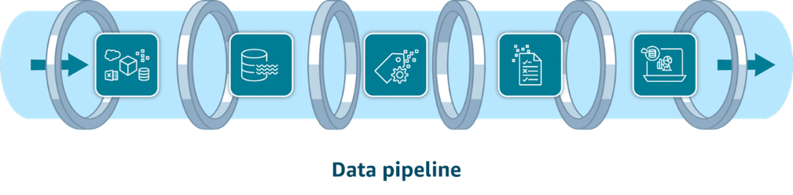
The process of a data pipeline is as follows:
- Data ingestion services - Data ingestion involves moving data from source systems into your chosen storage solution. Use real-time ingestion when the data is needed immediately. Use batch ingestion when some latency is tolerable.
AWS ingestion models:
Amazon Kinesis Data Streams – You can use Kinesis Data Streams for real-time ingestion of terabytes of data from applications, streams, and sensors. This serverless service even provides automatic provisioning and scaling in on-demand mode.
Amazon Data Firehose - Firehose is an option for data ingestion in near real-time. This fully managed service provides automatic provisioning and scaling. It also delivers data within seconds to data lakes, warehouses, and analytics services.
The key difference: Kinesis Streams is for when you need to do something with the data in real time. Firehose is for when you just need to move the data somewhere reliably.

2.Data storage services - Data can come from many different sources. To gain insights, data is commonly consolidated into a single location. There are two storage options for this. Flexible data lakes store vast amounts of raw data. Alternatively, the more structured data warehouses are optimized for business intelligence.
AWS Storage services:
S3 - Amazon S3 is a popular choice for data lakes. This object storage service can securely house virtually any amount of structured or unstructured data. Amazon S3 is also fully elastic, automatically scaling as you add and remove data.
Amazon Redshift – redshifts work similar to an RDS but for analytics. While RDS is built for complex relationships redshift is built to analyze and query Hugh amounts of historical data, it is a data warehouse analytics can pull from.
In a real pipeline they work together:
- Data lands in S3 first (cheap, flexible, keeps raw data)
- Glue or Firehose transforms and loads it into Redshift
- Business analysts run SQL queries on Redshift for reports and dashboards
So S3 is the lake where everything is stored cheaply, and Redshift is the engine where you actually analyze it.
3. Data cataloging services - Cataloging your data with metadata provides an inventory of your organization's data.
AWS Glue Data Catalog - AWS Glue Data Catalog provides a centralized, scalable, and managed metadata repository that enhances data discovery. It improves the overall efficiency of data pipelines by delivering metadata to various data stores and analytics services.
4. Data processing services - Data processing services clean and transform your data so it's ready to be analyzed.
AWS Processing services:
AWS Glue – glues job is to clean the data as part of the ETL process. Its second feature is data cataloging, it maps out that same data before sending it forward giving the next function a "map" of the data to make it easier to use.
Amazon EMR - Amazon EMR is ideal for large-scale data processing and organizations with existing big data expertise. It automatically handles infrastructure provisioning, cluster management, and scaling. Amazon EMR supports popular big data frameworks like Apache Spark, Apache Hadoop, and Apache Hive.
5.Data analysis and visualization services - Queries and visualization tools help you to develop important insights about your data.
AWS visualization services:
Amazon Athena - With Athena, you can run SQL queries to analyze data in relational, nonrelational, object, and custom data sources. This fully managed serverless service can access data hosted on Amazon S3, on premises, or even in multi-cloud environments. It offers a cost-effective solution for data analysis because you only pay for the queries you run.
Amazon Redshift - Amazon Redshift is a fully managed data warehouse solution. Its columnar storage and massively parallel processing architecture make it ideal for analyzing large datasets. You can use it to perform complex SQL queries on large datasets for frequent, high-performance analytical workloads.
Amazon QuickSight - With QuickSight, both technical and non-technical users can quickly create modern interactive dashboards and reports from various data sources without managing infrastructure. Amazon Q in QuickSight provides natural language queries. it is the main tool for visualization in AWS.
Amazon OpenSearch Service - With OpenSearch Service, you can search for relevant content through precise keyword matching or natural language queries. Unified dashboards provide real-time data visualization as you analyze and monitor logs, traces, and metrics for various applications.
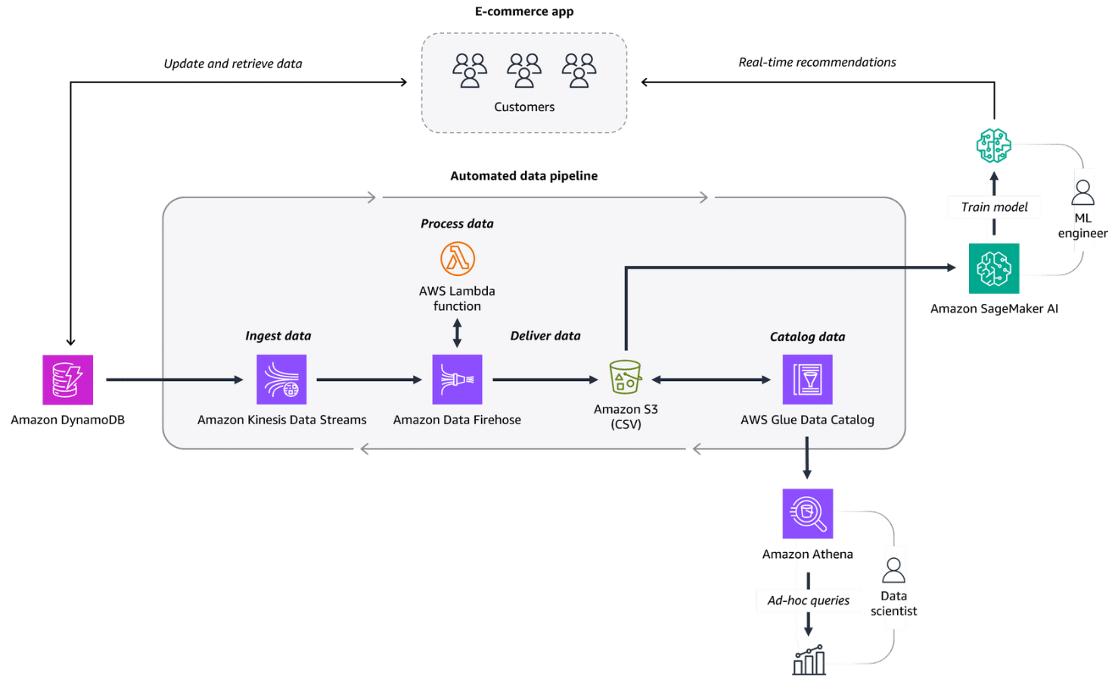
Security

Authentication and authorization:
Authentication is the process of verifying the identity of a user or entity through credentials like a username and password combination.
- Use case: An employee logs in to an employee portal.
Authorization grants users certain access rights and permissions that determine which actions they can perform in a system or application.
- Use case: An employee can only access their own employee records inside the employee portal.
IAM Roles and Users– IAM lets you create different roles and users to keep your application secured and protected, roles are temporary and give specific access just for the time needed for that user or function. While users are permanent and can be grouped which makes it much easier to keep track and helps secure your application.
Additional access management services:
1.AWS IAM Identity Center - IAM Identity Center centralizes identity and access management across AWS accounts and applications. IAM Identity Center can also connect to an existing identity source and provide your workforce with single sign-on access to all your connected AWS services and accounts. This is called federated identity management.
Federated identity management is a system that allows users to access multiple applications, services, or domains using a single set of credentials.
2.AWS Secrets Manager - Secrets Manager provides a secure way to manage, rotate, and retrieve database credentials, API keys, and other secrets throughout their lifecycle. This helps keep your applications, services, and IT resources safe.
3.AWS Systems Manager - Systems Manager provides a centralized view of nodes across your organization’s accounts and Regions and multi-cloud and hybrid environments. With this service, you can quickly access node information, such as ID and operating system details, and automate registry edits, user management, and security patching. Its main use is running patches and keeping inventory of your EC2s and other applications.
Nodes are connection points in a network, system, or structure.

Network and application attacks:
DOS Attack - In a denial of service attack, an attacker floods a web application with excessive network traffic. Legitimate customer requests are denied if the web application becomes overloaded and can no longer respond.

DDoS attacks - In a distributed denial of service (DDoS) attack, an attacker can use multiple infected computers (called zombie bots) to unknowingly send excessive traffic to a web application.

AWS protection through services:
1. AWS Shield - AWS Shield Standard is designed to automatically protect AWS customers from the most common, frequently occurring types of DDoS attacks at no cost. It uses a variety of analysis techniques to detect and mitigate incoming malicious network traffic in real time.
AWS Shield Advanced is a paid service that provides detailed attack diagnostics and the ability to detect and mitigate sophisticated DDoS attacks. It also integrates with other services, such as Amazon CloudFront, Amazon Route 53, and ELB.
2. AWS WAF - AWS WAF is a web application firewall that monitors network requests that come into your web applications. When a request comes into AWS WAF, it checks the IP address against a web access control list (web ACL). If the request comes from a blocked IP address on the web ACL, AWS WAF denies access. Legitimate requests are allowed access.
TIP: they will usually work together with shield protecting against common DDoS and someone trying to overwhelm your app and WAF protecting against exploiting.
Data encryption:

Encryption basics - Data encryption works like a lock and key mechanism. If you have the right key, you can access the encrypted data. Otherwise, you cannot access the data. For example, let's say you are protecting a customer's profile. An encryption key is used to turn the profile information into a randomized set of characters. A decryption key is used to access the customer's information, such as their name, only when it's needed by your application.

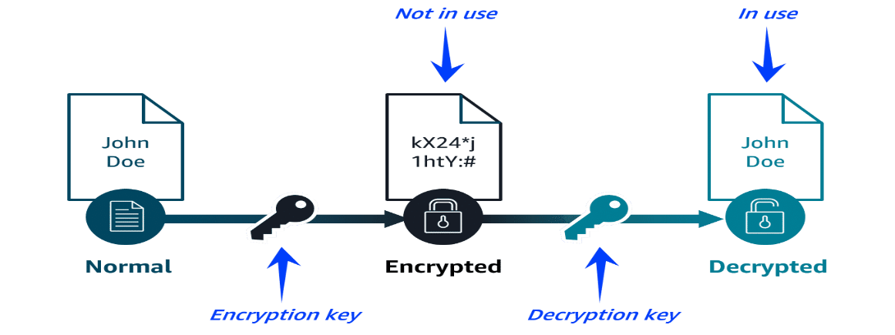

Types of data encryption:
- 1. Data encryption at rest: The data is idle and not moving, like when it's stored in a database.
- 2. Data encryption in transit: The data is moving between locations, like when it's being sent from a database to an application. SSL/TLS certificates are used to establish encrypted network connections from one system to another.
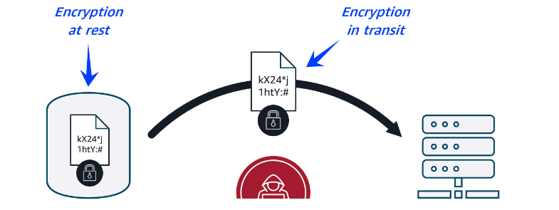

AWS data protection services:
1. AWS Key Management Service (AWS KMS) - You can use AWS KMS to create and manage cryptographic keys. These keys can then be used to encrypt and decrypt your data. You can also control the use of keys across a wide range of services and in your applications. For example, you can specify which IAM users and roles can manage keys. Your keys never leave AWS KMS, and you can temporarily disable them so they can no longer be used.
cryptographic key: a random string of digits used for locking (encrypting) and unlocking (decrypting) data.
2. AWS Certificate Manager (ACM) - AWS Certificate Manager (ACM)
ACM centralizes the management of your SSL/TLS certificates that provide data encryption in transit. It can be used to protect various AWS services and your connected on-premises resources.
SSL/TLS certificates are used to establish encrypted network connections from one system to another.

Detection and response services:
1.Amazon Inspector - Amazon Inspector helps improve the security and compliance of applications by running automated security assessments for Amazon EC2 instances, containers, and Lambda functions. It checks applications for security vulnerabilities and deviations from security best practices, such as open access to EC2 instances and installations of vulnerable software versions.
You can view completed assessments in the Amazon Inspector console. These assessments include a list of security findings prioritized by severity level. Each identified security issue includes a detailed description and a recommendation for how to fix it. You can also retrieve these findings through an API. Works like an anti-virus software.
2. Amazon GuardDuty - provides intelligent threat detection across your infrastructure and resources. GuardDuty identifies threats by continuously monitoring streams of your account metadata and network activity in your environment. It uses known malicious IP addresses, anomaly detection, and machine learning to identify threats more accurately.
You can review detailed findings about any GuardDuty detected threats in the AWS Management Console. Findings include recommended steps for remediation. You can also configure AWS Lambda functions to perform remediation steps automatically.
3. Amazon Detective - After a threat has been detected, you can use Amazon Detective to further investigate the root cause. Detective helps you analyze threats with interactive visualizations contained in a unified AWS Management Console view. These visualizations include resource and user interactions over a configurable timeline with recommended steps for remediation.
4. AWS Security Hub - Security Hub brings multiple security services together into a single place and format. With this service, you can quickly see your security and compliance state in one comprehensive view. Security Hub automatically aggregates security findings from AWS and partner services and organizes them into actionable, meaningful groupings called insights. It can accelerate time to resolution (TTR) with automated remediation.

AWS Pricing and Support
Pricing concepts:
1. pay as you go - With pay as you go, you can adapt to changing business needs and reduce the risk of overprovisioning or missing capacity.
2. save when you commit - For certain services, such as Compute services on AWS, Savings Plans offer savings over On-Demand prices when you commit to a 1-year or 3-year plan.
3. pay less by using more - With AWS, you can realize important savings as your usage increases. For some services, pricing is tiered, meaning the more you use, the less you pay

Driving factors of cost:
1. compute- For compute resources, you pay by a certain span of time, like by the hour or by the second. Unless you've made a reservation for which the cost is agreed upon beforehand, you pay from the time you launch a resource until the time you stop the instance.
2. Storage - You can choose from a broad portfolio of storage solutions with deep functionality for storing, accessing, protecting, and analyzing data. Pricing for storage largely depends on how much storage you have provisioned or how much you are using.
For some storage options, such as Amazon Simple Storage Service (Amazon S3), storage cost is tiered. This means you can optimize storage costs based on how frequently and quickly you need to access data.
3. data transfer - In most cases, there is no charge for inbound data transfer or for data transfer between AWS services within the same Region. There are some exceptions, so be sure to verify data transfer rates before beginning.
Outbound data transfer is aggregated across services and then charged at the outbound data transfer rate. The more data you transfer, the less you pay per gigabyte. For data storage and transfer, you typically pay per gigabyte.

AWS pricing and billing services:
1. AWS Organizations - AWS Organizations
AWS Organizations provides centralized management and governance of your AWS environment. Using AWS Organizations, you can create, group, and manage accounts. You can also apply security policies at the account level and consolidate billing with multiple accounts using a single payment method.
Use cases:
- Consolidate multiple AWS accounts into one central organization.
- Implement organization-wide policies.
2. AWS Billing and Cost Management dashboard - The AWS Billing and Cost Management dashboard centralizes cost management, showing current charges, usage, forecasts, and detailed breakdowns. It also provides tools to manage payments, view invoices, set budgets, and consolidate billing.
Use cases:
- Use helpful visualizations and billing reports of monthly AWS spend.
- Set up and manage payment methods.
3. AWS Budgets - AWS Budgets helps set custom budgets and sends alerts when costs, usage, or Savings Plans and Reserved Instances (RIs) utilization or coverage exceed defined thresholds.
Use cases:
- Set up alerts for when projected costs exceed predefined thresholds.
- Forecast future expenses based on current usage trends.
4. AWS Cost Explorer - AWS Cost Explorer
AWS Cost Explorer helps visualize, analyze, and manage AWS costs and usage with interactive graphs, reports, and forecasts. It provides insights into spending patterns, trends, and Reserved Instance recommendations.
Use cases:
- Analyze historical spending trends to identify cost-saving opportunities.
- Forecast future AWS costs based on current usage patterns to budget effectively.
- More of a long-term analyzer compered to billing and cost management dashboard.
5. AWS Pricing Calculator - Another helpful tool is the AWS Pricing Calculator. The AWS Pricing Calculator is a web-based planning tool that you can use to create estimates. You input specific configurations such as instance types, storage options, and data transfer volumes. Then, based on your configurations, you receive a detailed cost breakdown to help you budget for your AWS resource allocation.
Use cases:
- Estimate potential costs before deployment.
- Compare costs of different AWS services and configurations.

Types of AWS support:
1.Basic support – the basic and all accessible support plan for AWS, available for everyone who uses AWS automatically. Includes the basic package and customer support, great for startups and small businesses.
2. developer support - includes the same as basic BUT with added email support and better response time from customer support of 24 hours OR 12 when down.
3. business support - includes everything from before with an added full set of trusted adviser and really fast response time of 4 hours OR 1 when down.
4. Enterprise support – includes everything from before with a designated technical account manager and a full set of AWS trusted advisers for help, as well as 15 min response time.
AWS Marketplace: The AWS Marketplace is a digital catalog that includes thousands of software listings from independent software vendors. the marketplace has many services like:
- Software as a service
- Machine learning (ML) and AI
- Data and analytics
Monitoring, Compliance and Governance
Monitoring - to monitor your resources in an effective way in AWS you will need to provide insight into how they work, why they work and the problems that come with them. The progress you usually want for an effective monitoring is:
- Securing systems - making sure they are safe
- Monitoring activities – observing and analyzing them to detect problems
- Conducting audits – once in a while check that everything is working well and secure
- Ensuring compliance – make sure your security and efficiency meets the standards needed
AWS CloudTrail - CloudTrail tracks user activity and API usage in the AWS Cloud, on premises, and even with other cloud providers. CloudTrail provides a detailed history of API calls, so you can track changes and identify who made them and when. This helps you understand what actions were taken on your AWS resources.
Benefits: CloudTrail provides auditing, security monitoring, and operational troubleshooting. It also helps you prove compliance and improve your security posture.

Compliance - Compliance refers to your cloud resources and data adhering to relevant regulations, industry standards, and internal policies regarding security and data protection. AWS helps you keep your projects compliance by:
- Inheriting the latest security controls that AWS uses on its own infrastructure
- Third-party validation for thousands of global requirements
- Streamlining and automating compliance
- On-demand compliance reports
Compliance services in AWS:
AWS Artifact - the main tool on AWS to keep your projects in check with the compliance needed in your region, it offers compliance reports that way you can scale your applications infrastructure without worrying about its compliance with industry standard or the law.
AWS Config - AWS Config is a service that you can use to assess, audit, and evaluate the configurations of your AWS resources.
Benefits: AWS Config helps evaluate configurations against a desired state, manage resource configuration changes, and simplify troubleshooting and remediation.
AWS Audit Manager - Audit Manager is a service that continually audits your AWS usage to simplify risk and compliance assessment. It helps collect evidence and manage audit data.
Benefits: Audit Manager saves time with automated evidence collection, streamlines collaboration across teams, and helps ensure integrity of audits with read-only permissions.

AWS Organizations - Organizations helps you centrally manage and govern your environment as you grow and scale your AWS resources. It helps you manage policies for groups of accounts and automate account creation. You choose a main account and all other accounts are considered secondary, all bills go to the main account for easier organization.
Organizations also allows you to group accounts for easier access and management, you can assign each group its own policy's and restrictions which will help keep the project tidy. You can onlu assign policy's to users accounts or groups(OU).
Benefits: Organizations provides several benefits like quickly scaling your environment by programmatically creating new AWS accounts for resources and teams. It also helps by simplifying permission management through SCPs and managing and optimizing costs across your AWS accounts and resources.

Governance – as your operations scale you will need to keep track and to make sure your framework and policies are good enough to build on and adhere to your project.
Governance Services in AWS:
AWS Control Tower – control tower is our main tool in AWS for governance, it has two main features that help it do that. The first is guard rails, in control tower your able to create rails to make sure there will be no resource miss use and to alert you to any problems that may happen. The second feature is account factory, it is similar to EC2 lunch templet and allows you to quickly config an AWS account for use that way you can scale quickly and efficiently.
AWS Service Catalog - helps you create quick starts for account by having the ability to create and use templates for programs that are used in AWS such as roles, DS, S3 and more. If control tower creates the account quickly catalog fills it with what it needs to function.
AWS License Manager - License Manager is a service that helps you manage your software licenses and fine-tune your licensing costs.
Benefits: License Manager helps with visibility and control, tracking and managing licenses, and reducing the risk of noncompliance with licenses.
Other helpful programs:
AWS Health Dashboard - your main check program for making sure the health of your AWS accounts and the programs in them are healthy and are problem free.
Trusted Advisor – AWS helpful and constant adviser, it helps evaluate your application and gives advice on how to run it more efficiently and cheaper, its main goal is to help optimize your application and work.
IAM Access Analyzer - IAM Access Analyzer provides capabilities to set, verify, and refine permissions by analyzing external access and validating that your policies match your corporate security standards.
Benefits: IAM Access Analyzer provides benefits like refining permissions, validating IAM policies, helping you meet your least privilege goals, and automating IAM policy reviews.

Migrating to the AWS Cloud
The Three phases of the migration process – if you want to upload your data and move to AWS there are three different phases to the process:
1. assess - In this phase, you build the business case for the migration and assess your readiness. One of the services used in this phase is the Migration Evaluator.
2. mobilize - In this phase, you prepare the organization and mobilize the resources needed for the migration. Two services you might use in this phase are AWS Application Discovery Service and the AWS Migration Hub.
3.migrate - In this phase, you use your strategy, plan, and the best practices to migrate
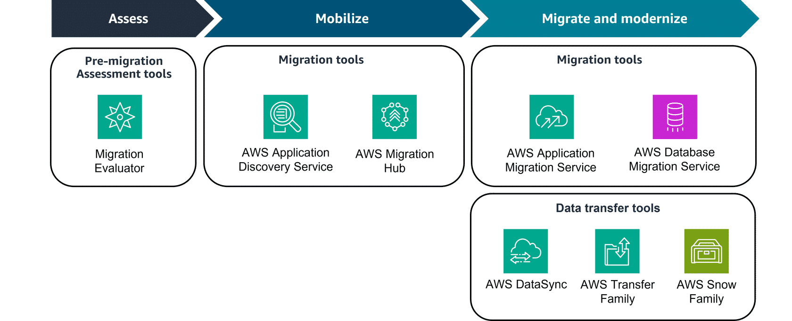
AWS CAF - The AWS CAF is a framework that brings AWS experience and best practices to companies preparing to migrate to the AWS Cloud. The framework provides tools to help accelerate the migration journey, organize resources, and align management during the transition.
Benefits: AWS CAF provides benefits for migrations to reduce business risk and improve sustainability and corporate transparency. They can reduce operational costs, increase productivity, and improve customer experience in their new cloud environment.
Migration strategy's - When customers are migrating applications to the cloud, they can use seven common migration strategies. The decision on which strategy depends on factors such as the complexity of existing applications, business goals, time constraints, and available resources. Often, organizations will use a combination of these strategies across their application portfolio.

Strategies:
1. rehost – moving your application to AWS without changing them in any way, also called a lift and shift great for small scale or fast change.
2. Replatform – the same as a reshot only with the added change of optimization, no added code or change of core code.
3.Relocate – possible of application is already a virtual machine and its main ideal is to change the hosting location to the cloud.
4. refactor – the reimagining of an application to make it possible to move it to the cloud, great in cases where you know you will need to scale up or improve performance.
5. repurchase – the change of a software vendor to a cloud based one.
The last two strategies are not a full move to the cloud but tools in case of it:
6. retain – the choice to not move some of your services to the cloud either because doing so is too costly, it's important to keep it constantly running or because it’s not available or ready to be retired soon, in that case you keep it running until its not needed or replaced by something you have built in the cloud.
7. retire – removing an application since it will not be needed anymore in the cloud.
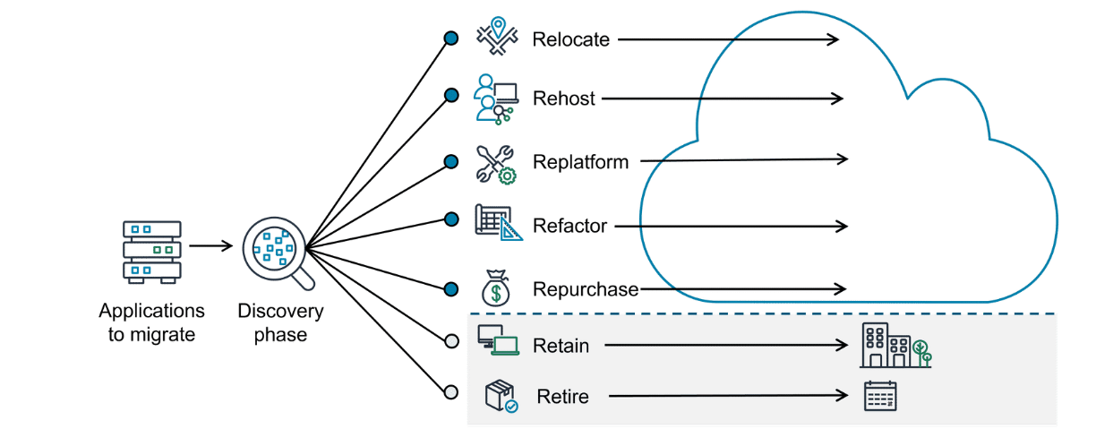

Migration services and Tools – for each phase of migration there is a tool in AWS to use:
Assess phase
Migration Evaluator - The Migration Evaluator is a migration assessment service that helps you create a business case for AWS Cloud planning and migration. It does this with a data driven approach, analyzing your current state, target state, and developing a migration readiness plan with projected cloud costs.
Benefits: The benefits include removing the guesswork when migrating. It provides visibility into multiple cost-effective cloud migration scenarios. It also gives insights on reusing existing software licensing, which can further reduce costs.
Mobilize phase
Application Discovery Service - The Application Discovery Service discovers on-premises server inventory and connections. It gathers configuration, performance, and connection details for both servers and databases to create a detailed migration plan.
Benefits: With Application Discovery Service, you get a comprehensive snapshot of your on-premises inventory. You also can integrate discovery data with other services like Migration Hub and protect the data Application Discovery Service collects.
Migrate and modernize phase
Application Migration Service - Application Migration Service is a tool to move and improve your on-premises and cloud-based applications. It helps customers streamline, expedite, and reduce the cost of migrating and modernizing applications.
Benefits: The benefits include support to migrate from any source infrastructure that runs a supported operating system (OS). It makes it possible to modernize your applications during migration. You can maintain normal business operations during the application replication process and also reduce costs by using one tool for a wide range of applications.

The Migration Hub - The Migration Hub is a centralized hub to take you from discovery, assessment, planning, and execution of your migration. It provides tools, guidance, and automated recommendations to collaborate with your team and track your migration.
Benefits: With the Migration Hub, you have one location to go for your migration and, expert guidance in the form of prescriptive journey templates. Another benefit is cost savings because there is no charge to use Migration Hub.

Migrating databases - Migrating your database to the cloud can provide an opportunity to redesign and improve your database architecture. Because legacy systems and requirements change over time, you might also consider whether to migrate to an AWS managed database service or an open source database to reduce licensing costs.

Services for Migrating databases:
DMS - The AWS Database Migration Service (AWS DMS) makes it possible to quickly and securely migrate databases and perform ongoing data replication tasks for live databases and data warehouses.
Benefits: AWS DMS provides benefits for migrating databases including maintaining high availability and low downtime during the migration process. It supports homogenous and heterogenous migrations. It also makes it possible to migrate terabyte sized databases at a low cost.
SCT - AWS SCT makes it possible to convert database schemas and code objects (like stored procedures, views, and functions) from one database engine to another. AWS SCT can even give you estimates of how big of an effort a conversion is, which helps with planning. And data that can't be converted automatically is marked for manual conversion.
Benefits: AWS SCT provides benefits to simplify database migrations by automating schema analysis, recommendations, and conversion at scale. It is compatible with popular databases and analytics services as source and target engines. It can save weeks or months of manual time and resources, which are typically required in conversions.
Services for Transferring data to and from the AWS Cloud:
Datasync - AWS DataSync is specifically designed for automating and accelerating data transfer. DataSync simplifies and accelerates moving large amounts of data between on-premises storage and AWS storage services like Amazon Simple Storage Service (Amazon S3). It automates many aspects of the transfer process, including running instances, encryption, and network optimization.
Benefits: The benefits include streamlining and accelerating secure data migrations. DataSync manages data movement workloads with bandwidth throttling, migration scheduling, task filtering, and task reporting. It also provides rapid data replication.
Transfer Family - AWS Transfer Family
The AWS Transfer Family makes it possible to seamlessly manage and share data with simple, secure, and scalable file transfers. This service provides fully managed support for secure file transfers over FTP, Secure File Transfer Protocol (SFTP), File Transfer Protocol Secure (FTPS), and other protocols. It helps you transfer files directly into and out of AWS storage services like Amazon S3 and Amazon EFS.
Benefits: The benefits include simplifying the process of setting up and managing file transfers and reducing the need for complex infrastructure management. The Transfer Family provides secure data transfer with encryption and authentication, to ensure data integrity and confidentiality. It is built to scale and streamline workflows.
Direct Connect - AWS Direct Connect is a service that makes it possible for you to establish a dedicated private connection between your network and virtual private cloud (VPC) in the AWS Cloud. Because it is your dedicated connection, it is a fast, reliable, and secure way to transfer your data or files.
Benefits: Direct Connect helps reduce network costs and increase amount of bandwidth.
Alternatives for data migration:
Snowball Edge Storage Optimized devices - AWS Snowball Edge Storage Optimized devices are a great solution for offline data migration where connecting to the internet might not be an option. These devices deliver high performance NVMe storage, making it possible to simplify multi-petabyte data migrations from on-premises locations to AWS.
Benefits: The benefits include delivering better compute performance and larger storage capacity with gigabytes of data per second for data migration workloads with offline requirements.
Architected solutions
AWS specialized Services:
Development services
CodePipeline - CodePipeline is a fully managed CI/CD service that automates the build, test, and deploy phases of your release process. This helps developers streamline software release workflows and reliably deliver new features and fixes without needing to provision servers.
CI/CD pipelines automate the integration, testing, and deployment of code changes to help provide quick and reliable software delivery.
CodeBuild - CodeBuild is a fully managed continuous integration service that compiles source code, runs tests, and produces software packages for deployment. It automatically scales to meet demand, and you only pay for the build time that you use.
X-Ray - X-Ray is a powerful tracing, debugging, and performance analysis tool that helps developers visualize application behavior. With X-Ray, developers can quickly identify performance bottlenecks, troubleshoot issues, and optimize applications for better efficiency and reliability.

AppSync - AWS AppSync is a fully managed GraphQL service. With AWS AppSync, developers can create a single GraphQL API that can securely access, manipulate, and combine data from multiple data sources. This helps developers connect frontend applications with backend data.
With GraphQL, a query language for APIs, clients request only the specific data they need.
Amplify - Amplify helps you streamline the process of developing, deploying, and managing secure and scalable full-stack applications on AWS. With Amplify, developers can quickly add features, like authentication, APIs, storage, and hosting, with minimal infrastructure management.
Full-stack applications are software systems that involve both frontend (user interface) and backend (server-side) development.
Business application services
Amazon Connect - Businesses can use this AI-powered contact center service to efficiently set up and operate a scalable customer service call center. Amazon Connect provides capabilities for call routing, recording, and analytics while integrating seamlessly with other AWS services.
Amazon Simple Email Service - Amazon SES is a scalable and cost-effective email service provider that can be integrated into any application for reliable, high-volume email automation. It helps businesses optimize the delivery of transactional and marketing emails, resulting in enhanced customer engagement.
End-user computing services - In modern businesses, IT departments often need to provide remote access to resources like virtual desktops and applications. These services help you do that:
AppStream 2.0 - AppStream 2.0 is a fully managed service that streams applications from the cloud directly to any compatible device. This includes software-as-a-service (SaaS) applications and applications converted from desktop to SaaS without code revisions. This provides instant access to powerful software without the need for high-end local hardware.
Amazon WorkSpaces - WorkSpaces is a fully managed cloud-based desktop computing service. With WorkSpaces, employees can securely access their work environment from any device with an internet connection. Employees can perform the same tasks as if they were on a physical office computer, while companies can benefit from cost-efficiency and easy administration.

AWS Well-Architected Tool - The AWS Well-Architected Tool (AWS WA Tool) is a free service that helps assess and improve cloud workloads based on the six key pillars: Operational Excellence, Security, Reliability, Performance Efficiency, Cost Optimization, and Sustainability. It offers workload reviews, milestone tracking, and custom lenses for tailored evaluations and improvement plans. Integrated with AWS services like AWS Identity and Access Management (IAM) and APIs, it supports team collaboration and continuous progress tracking. The AWS WA Tool is ideal for architects, engineers, and compliance teams, and it promotes consistent, actionable, and well-documented architecture reviews.

